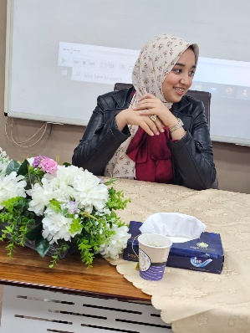

**Biography**

**Ola farghaly Mostafa**

***Department of food hygiene Faculty of Veterinary Medicine Assuit University.***

**Personal Data :**

Name : ola farghaly Mostafa ahmed

Graduation Year : 2023

Study at : Faculty of Veterinary Medicine Assuit University.

Date of birth : 28\9\1999

Phone number : 01112135659

Address : Assuit \ abutige

E-mail : [Olafarghaly@aun.edu.eg](mailto:Olafarghaly@aun.edu.eg)

[Olafarghaly2019@gmail.com](mailto:Olafarghaly2019@gmail.com)

***# Working as: Demonstrator of food hygiene at Faculty of Veterinary Medicine Assuit***

***University.***

**# Teaching to undergraduate students >>>>> practical courses of Meat hygiene , Safety and Technology**

# Training & courses :

***Effective communication skills***

***The training program of credit hour system***

***The training course on publishing research in international journals***

***The training course*** ***Foundations of measurement, evaluation and ethics***